**Project 3: Light Detecting Vehicle**

Your next project will use sensors, an H-bridge, and DC motors. Your goal is to make a vehicle that can maneuver through a predetermined track. Each vehicle will have 3 attempts to complete the track. The time of each attempt will be recorded. The 8 vehicles that complete the track in the shortest time will move on to a 1 v 1 elimination tournament. The race will have two parts.

**Part 1 of the Race**:

**Autonomous mode:** In this mode your vehicle will have **15 seconds** to get as far as possible through the track on its own(through programming).

**Part 2 of the Race:**

**TeleOp Mode**: In this mode your vehicle should be programmed to follow a light. You or your partner will be equipped with really bright flash lights that will lead the vehicle through the track.

*Note: Some of the rules or details might change, so make sure that you pay attention to all the updates.*

**Grading:**

For making a vehicle that can participate in the race will earn you a minimum grade of 80. Each vehicle will have 3 attempts to complete the track

After the 80 points

1. +2 points for reaching Bs at least once.
2. +3 points for reaching Cs at least once.
3. +2 points for reaching A4 at least once in autonomous.
4. +4 points for reaching B1 at least once in autonomous.
5. Earn a 90 if you finish the track at least once. *(This overrides 1 and 2)*
6. Top 8 will compete for the grades 96 – 100.

The 8 vehicles that complete the track in the shortest time will move on to a 1 v 1 elimination tournament. The farther the vehicles make it in the tournament the higher the grade.

You can also earn a higher grade by winning one of the various awards.

Best Autonomous, Best Looking Vehicle, fastest time,…

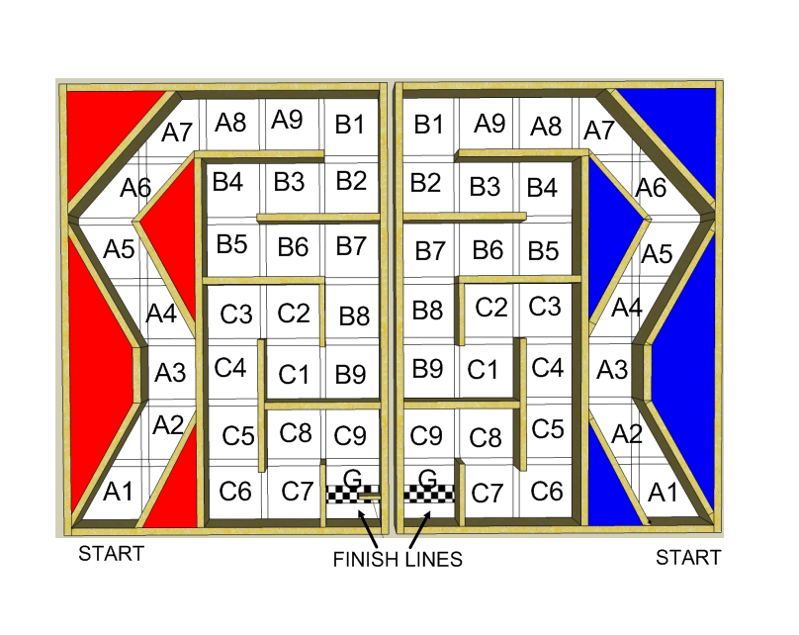**THE TRACK**

**Project requirments:**

1. You **must** work with a partner.
2. Your wheels cannot be premade wheels. *FOR EXAMPLE: No Lego wheels or toy wheels.*
3. You can only use the motors provided to you.
4. The only sensors that you can use are the photoresistor, flex sensor, and ultrasound sensor.
5. During TeleOp mode the only way that you can drive the vehicle is by using the provided flash light.
6. Your frame can be made from any approved material.